***Assignment Part-3***

Playing with files

1. Create a file like **nano file1.txt**

o Edit some data and then save the file   
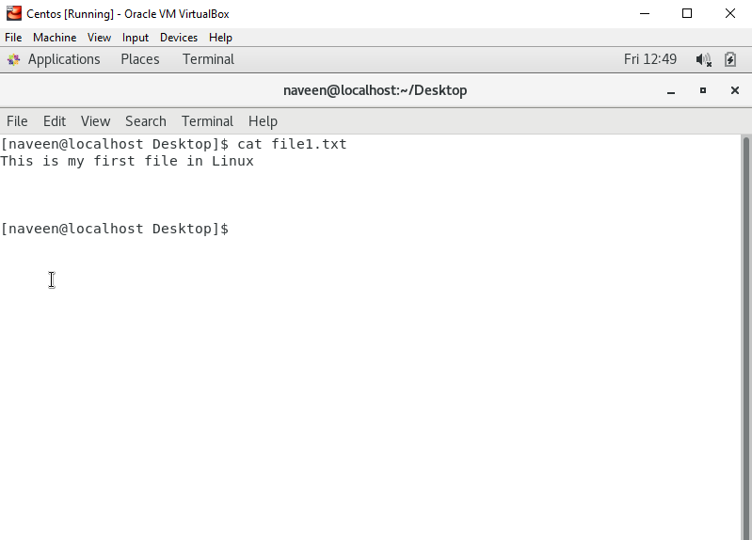

2. Now we will copy date from file1 to new file2

**o cp file1.txt file2.txt**

o Then see the output of file2.txt, **cat file2.txt**

o Give screenshot   
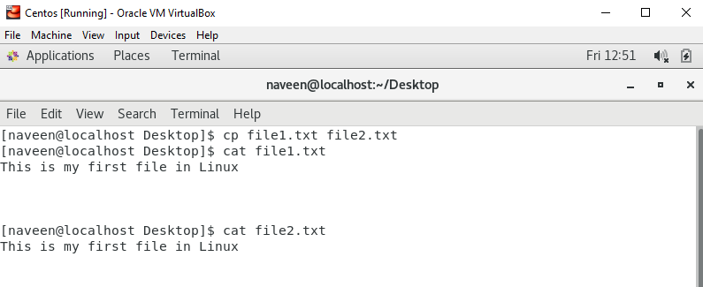

3. Now we will move the file2.txt to new folder **/home**

o **mv file2.txt /home**

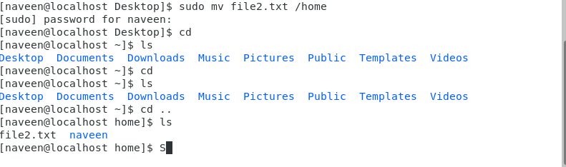

o Then go to **home** directory and check **ls,** file exits or not?

o Given screenshot



4. Then we create a new **file3.txt and file4.txt** in **home directory** and add

content in it.

o Now do **echo “Hello I am newline” > file3.txt** and provide the

output of file3.txt   
  
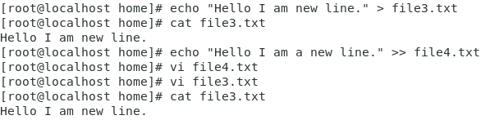

o Now do **echo “Hello I am newline” >> file4.txt** and provide the

output of file4.txt

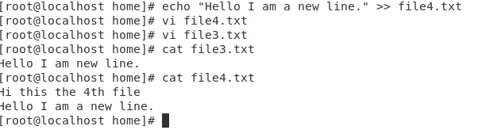

o Tell the different between both step you follow and the reason

behind it   
  
*In file3 we can see that previous data has been replaced by the new data, on the other hand in file4 the new data has been added to previous one. This is because of the double greater than sign (>>) in the command.*

5. For remove a file or directory you can use the below two commands

**o** To delete a file – **rm <any_filename>o** To delete a directory - **rmdir <any_directoryname>**

